LTE-572A 802.11ah HaLow Wireless Router
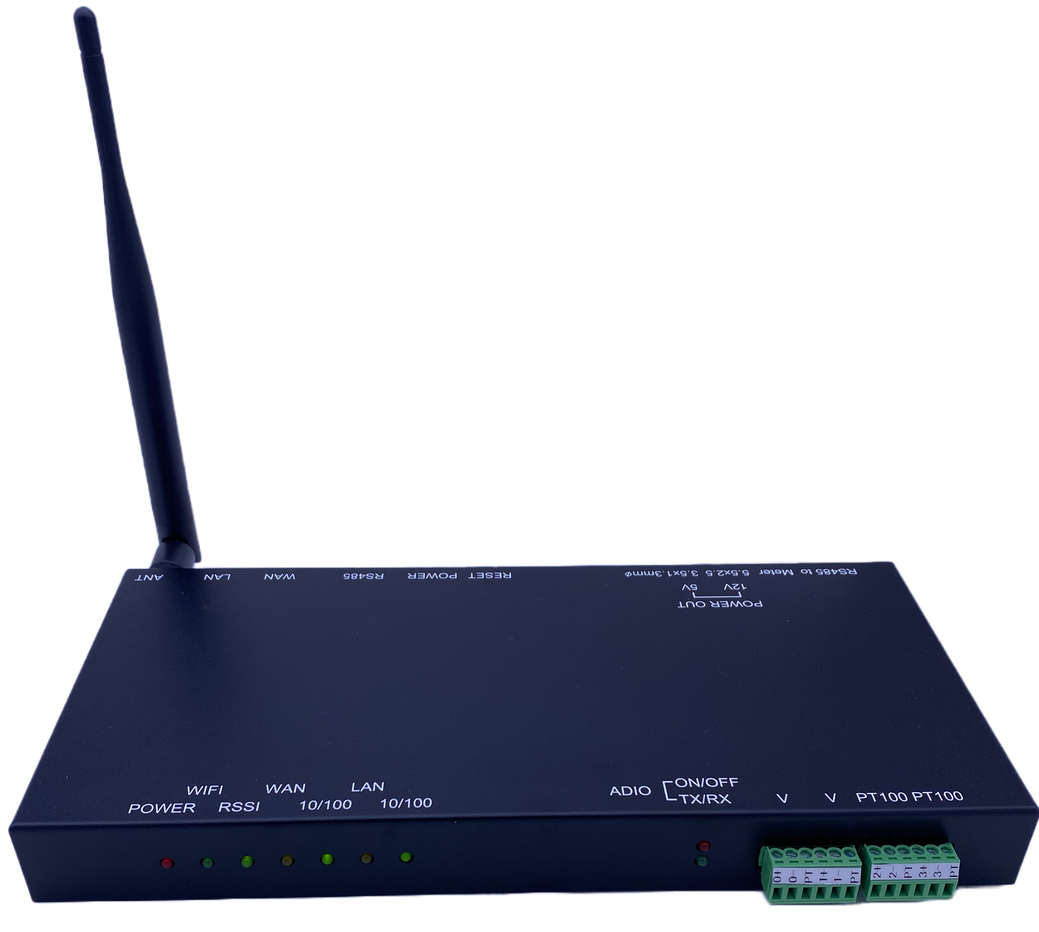
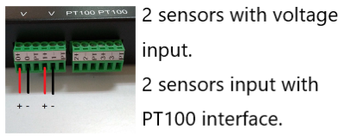
LTE 572A is a versatile and easy-to-use 802.11ah wireless router that is powered by the NRC7292 with ADIO capability.
It provides greater range (1km+) and higher bandwidth (up to 4Mbps)
over other Sub 1GHz protocols.

KEY FEATURES
• Both Access point and station mode
•Security: OPEN, WPA2-PSK(AES), WPA3-OWE,WPA3-SAE
• 902.0 ~ 928.0 MHz Frequency
• +23dBm Transmit Power
WiFi
802.11ah HaLow Supports 1/2/4 MHz bandwidth
INTERFACE
• 2 10/100Mbps LAN port，Auto MDI/MDIX
• 1x12VDC power input, 1x5Vdc power
Output, 1x12Vdc power output to provide
power to external sensor devices.

• External 1 SMA antenna for HaLow.
•1 RS485 port to connect serial device,
Such as power meter or extra AD I/O
device.

Button:
System Reset

LED
Power, wifi status,, 2 10/100 LAN ports, Link/Act,WPS

Embedded system: Yocto Linux Router

Protocol: TCP, FTP, PPTP, HTTP,HTTPS, TFTP, DHCP, NAT, IPSec Pass through, ICMP, IGMP, RIPv2, RIP, OSPF, SNMP, RMON, QoS.
Optional: VPN client or gateway, IPSec client. 4G mobile connection.

Real time clock
• 1 RTC battery to support log data up to 7 days

Others
• Size 24.5cm x 2.5cm x 11.5cm
• Weight 0.5 kg
• Operating temperatures
• Normal operating conditions -30...+75 °C

LIGHTSPEED International Co.
No.20, Lane 526 NiuPu East Rd. Hsin Chu Taiwan
Tel: +886 3 5396570 Fax:+886 3 5401872
Web : www.lightspeed.com.tw
Contact : peter@lightspeed.com.tw

